URR-18 Write your Roll number
 |  |  | KAKATIYA INSTITUTE OF TECHNOLOGY & SCIENCE, WARANGAL  (An Autonomous Institute under Kakatiya University, Warangal)  FACULTY OF ENGINEERING AND TECHNOLOGY  B.Tech. (CSM & CSN) – V-Semester  Minor Examination – I
U18AI609/ U18CN506R22 MACHINE LEARNING
Time: 40 Mins.] |  |  |  |  |  |  |  |  | [Max. Marks: 10
Date: 22.08.2023
Note: 1. Answer all the Questions.
 |  |  |  |  |  |  |  |  |  |  | Marks |  |  | CDLL |  | CO
1. | a. | List the type of problems that can be solved by supervised, unsupervised and reinforcement learning |  |  |  |  |  |  |  |  | [1] |  |  | Ap |  | CO1
 | b. | Consider the following three-class confusion matrix (plus marginals):  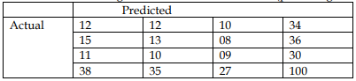  Make use of given confusion matrix and find the sensitivity. |  |  |  |  |  |  |  |  | [1] |  |  | R |  | CO1
 | c. | List various output models of machine learning along with examples. |  |  |  |  |  |  |  |  | [1] |  |  | Ap |  | CO1
 | d. | Distinguish between feature construction and feature transformation. |  |  |  |  |  |  |  |  | [1] |  |  | Ap |  | CO1
2. |  | Illustrate the working process of K-Means clustering with a numerical example. Illustrate it with neat sketches wherever required. |  |  |  |  |  |  |  |  | [2] |  |  | Ap |  | CO1
3. |  | Use Naïve Bayes Classifier to estimate the class probability values for the new instance –{Color- Green, Legs-2, Height-Tall, Smelly-No}  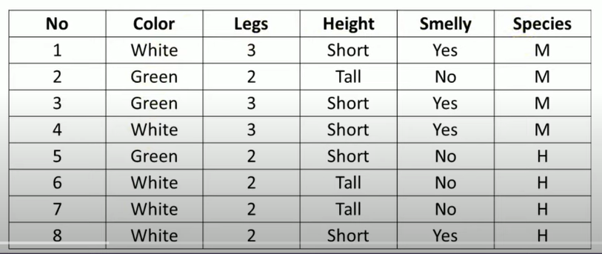 |  |  |  |  |  |  |  |  | [2] |  |  | Ap |  | CO1
4. |  | Compute the major evaluation metrics extended from the below confusion matrix.  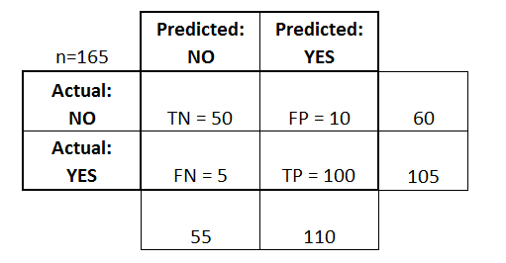 |  |  |  |  |  |  |  |  | [2] |  |  | Ap |  | CO1

--- Question Paper Ends ---

Paper set by:

Dept. of CSE(N)
Faculty Name | Signature
Dr.Jothi Prabha Appadurai
Smt. R. Swetha.

